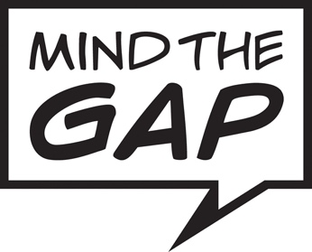
Equal Opportunities Monitoring Form

It is helpful for Mind the Gap to understand who we are reaching through our recruitment process. We would be grateful if you can complete this form and return it with your completed application.

It is up to you what information you provide. You do not have to answer a question if you don’t want to. Simply tick the box “Prefer not to say”.

Any information you provide will be treated as strictly confidential. It will not be used as part of the recruitment short-listing or selection process. All information will be anonymised, and only be used for monitoring purposes.

How do you describe your gender?

Female

Male

Non-Binary

In another way

Prefer not to say

How do you describe your sexual orientation?

Bisexual

Gay/Lesbian

Heterosexual/Straight

Queer

In another way

Prefer not to say

How do you describe your ethnicity?

White British

White Irish

White Gypsy or Irish Traveller

Any other White background

White and Black Caribbean

White and Black African

White and Asian

Other multiple ethnic background

Indian

Pakistani

Bangladeshi

Chinese

Other Asian background

African

Caribbean

Other Black background

Arab

Any other ethnic group

prefer not to say

Do you consider yourself to have a disability?

Yes No Prefer not to say

If yes, how do you describe your disability (tick all that apply)?

Visual impairment

Hearing impairment or d/Deaf

Learning disability or disabilities

Physical disability or disabilities

Mental health condition

Other long-term condition

Prefer not to say

If there anything else you would like to tell us, please do so below.

