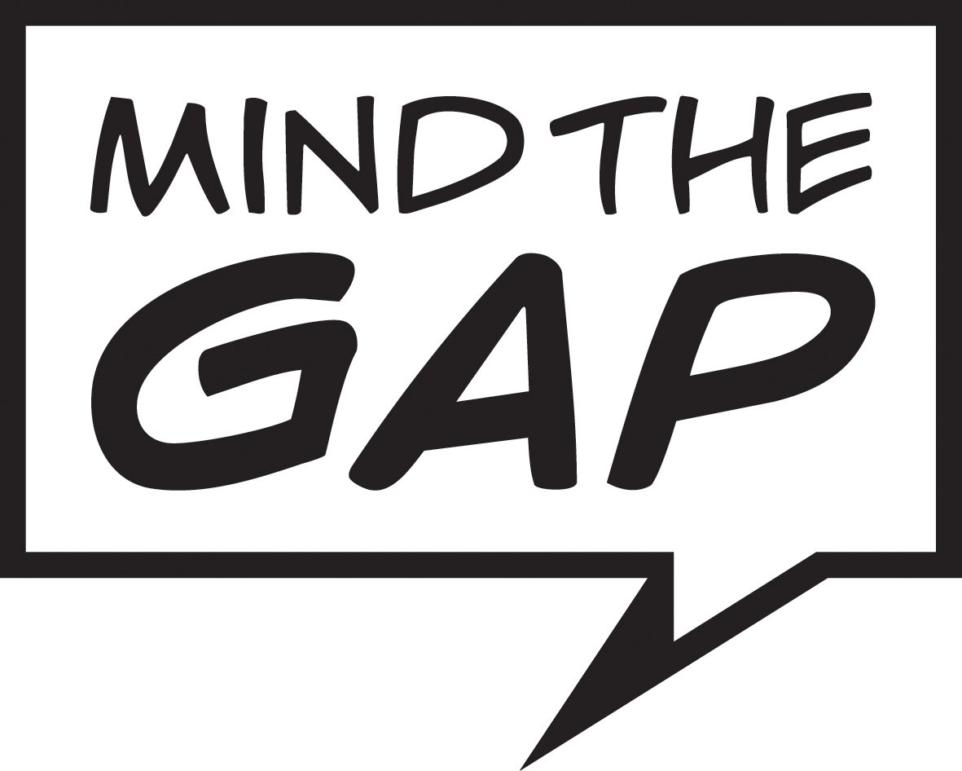

Job Description

Job Title: Creative Support Worker

Salary: £23,620 to £25,409

Responsible to: Academy Director

Core Purpose:

Mind the Gap is looking for a Creative Support Worker to join its friendly and welcoming team. We are looking for someone to support our team of Artists on various projects, developing their performance and leadership skills, particularly one of our female artists who has been cast in a touring production WALDO by Extraordinary Bodies. This role is not open cis-gender men. This is due to the access requirements of the Artist you will be working with.

The Creative Support Worker will support the engagement and participation of the performer both in rehearsals and on tour. They will also provide pastoral support whilst working with the performer as well as undertake any administration needed.
The post holder will support the performer away from Mind the Gap Studios when rehearsing in Bristol and touring to 8 different national venues. From July 2023 when supporting other Artists, this is most likely to be from Mind the Gap Studios in Bradford.
.
This role does require the successful candidate to be a car driver.

Key areas of responsibility:

- To support the engagement and creative development of the Artists, which includes:

- Providing practical support for Artists in relation to their professional engagement with MTG within the building.
- Developing a creative relationship with the Artists and/or performer.
- Providing practical creative support for the Artists and/or performer during rehearsals and ensure active engagement in any process.
- Providing writing / transcribing support during rehearsals required and evaluation capturing sessions.
- Supporting the Artist/performer in preparation for rehearsals which may include line learning and/or choreography.
- Supporting the Artist/performer to have a voice within the creative team and support any communication that may be needed.
- If an Artist is working for another company, liaising with the creative team as and when needed.
- Supporting Artists with auditions or attending other relevant opportunities as part of their development.
- Supporting facilitators in practical session which may include some administration e.g. scheduling appointments, email communications.

- To support the pastoral needs of the Artists/performer which will include:
- Liaising with Mind the Gap’s Academy Director and/or Head of Learning & Support regarding access and support needs.
      - Providing pastoral and safeguarding support during sessions at the Studios.
      - Providing pastoral and safeguarding support during rehearsals and on tour.
      - Liaising with Mind the Gap’s Safeguarding Lead regarding any concerns whilst working with the Artists/performers.
- Responsible for ensuring any Covid-19 guidelines that are in place are met both at MTG Studios and away from the building.
- Provide supervision to ensure the welfare and health & safety of the artist/performers when required, e.g. at lunchtimes, breaks and evenings when on tour.
- Providing travel support to and from places that the Artist/performer may need support with. This will include both car driving and travelling by train.

- To support the administration of Artists projects which will include:
- Responsibility for organising schedules for Artists/performer when needed.
- Organising theatre or event trips that are relevant to the Artists/performer’s development.
- Liaising with external companies that the Artists/performer are working with regarding schedules.
- Booking transport and accommodation for the performer/s and yourself during touring periods.
- Supporting financial administration that may include requesting invoices and managing expenses.
- Supporting Artists/performer to send emails as and when needed.
- Providing over all admin support for the ensembles of Artists, which will include letter writing, making phone calls and emails.

General expectations and responsibilities

Mind the Gap’s Employment Handbook sets out in detail the company’s policies and procedures and forms an essential part of the contractual arrangement between the company and its employees.

In their daily conduct all staff are required to:
- To have a full DBS check or be willing to have a DBS to undertake the role

- be flexible, constructive and adaptable;

- be respectful to colleagues including learning-disabled & autistic company members, and to work co-operatively with other team members including freelance staff;

- support the induction of new staff in MTG policies and procedures;

- manage their own administrative tasks, e.g.: answering phones and dealing with post and emails to support the smooth running of the company;

- work within agreed budgets, and to supply relevant records of expenditure and receipts in accordance with the company’s financial accounting systems;

- participate in and contribute to individual appraisal, one-to-one support and review processes;

- participate in training as required;

- contribute positively and constructively to monitoring, evaluation and review procedures as required by the company and funding / stakeholder bodies;

- actively support the engagement of people with learning disabilities in all areas of Mind the Gap’s work;

- provide supervision to ensure the welfare and health & safety of company members when required, eg: at lunchtimes and breaks;

- respect issues of confidentiality, particularly as this relates to other staff and company members.

All staff may be asked to undertake other tasks to further the work of Mind the Gap as may be reasonably requested by senior managers and the Board of Trustees.

